**AWS Developer: Designing and Developing_Launching Instances in AWS**

Basic unit in EC2 is instance each instance req software installed on it to run. it is available as ami..

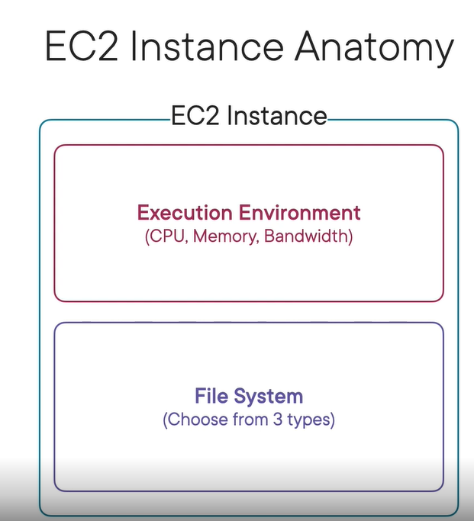

**EC2 Instance file system**

* **Instance Store :** Physically connected, basic hard drives
* **Elastic block store:** Independent, networked volume
* **Elastic file system:** Scalable, independent, networked volume

AMI Visibility

* Public - Visible to everyone
* Explicit - Visible to who you allow
* Implicit – private

**EC2 Instance Classes**

* **On Demand Inst :** Pay for what we use, No Commitment, Easy to create and delete, good for applications needing scaling,
* **Reserved inst :** Commitment for a period of time, commitments range from 1- yrs, discounts up to 75% off, Good for stable companies
* **Spot instances** **:** Bid for computing resources, uses spare, unused EC2 capacity, discounts up to 90% off, No guarantee, good for flexible computing jobs

**The AWS REST API**

* Each AWS REST API request must be signed
* The AWS SDK is a code interface to the REST API

